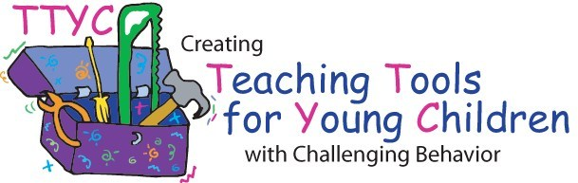  Lentini, R., Vaughn, B. J., Fox, L., & Kwang-Sun Blair (2009). Creating teaching tools for young children with challenging behavior (3rd edition). Tampa, Florida: University of South Florida. |  | Lentini, R., Vaughn, B. J., Fox, L., & Kwang-Sun Blair (2009). Creating teaching tools for young children with challenging behavior (3rd edition). Tampa, Florida: University of South Florida.
Lentini, R., Vaughn, B. J., Fox, L., & Kwang-Sun Blair (2009). Creating teaching tools for young children with challenging behavior (3rd edition). Tampa, Florida: University of South Florida. |  | Lentini, R., Vaughn, B. J., Fox, L., & Kwang-Sun Blair (2009). Creating teaching tools for young children with challenging behavior (3rd edition). Tampa, Florida: University of South Florida.
Lentini, R., Vaughn, B. J., Fox, L., & Kwang-Sun Blair (2009). Creating teaching tools for young children with challenging behavior (3rd edition). Tampa, Florida: University of South Florida. |  | Lentini, R., Vaughn, B. J., Fox, L., & Kwang-Sun Blair (2009). Creating teaching tools for young children with challenging behavior (3rd edition). Tampa, Florida: University of South Florida.
Lentini, R., Vaughn, B. J., Fox, L., & Kwang-Sun Blair (2009). Creating teaching tools for young children with challenging behavior (3rd edition). Tampa, Florida: University of South Florida. |  | Lentini, R., Vaughn, B. J., Fox, L., & Kwang-Sun Blair (2009). Creating teaching tools for young children with challenging behavior (3rd edition). Tampa, Florida: University of South Florida.
Lentini, R., Vaughn, B. J., Fox, L., & Kwang-Sun Blair (2009). Creating teaching tools for young children with challenging behavior (3rd edition). Tampa, Florida: University of South Florida. |  | Lentini, R., Vaughn, B. J., Fox, L., & Kwang-Sun Blair (2009). Creating teaching tools for young children with challenging behavior (3rd edition). Tampa, Florida: University of South Florida.

